# Assignment 1

## Executive Summary

This report is to find the optimal solution for ComfortHealth to schedule the recruitment and scheduling of health professionals while minimizing the costs. If ComfortHealth is to meet all demands in all regions, it was estimated that ComfortHealth will be able to produce a profit of $133,756,83.

Although the model is configured to meet all demands, it was found that the optimal solutions produced by the model cannot satisfy all demands every year. This report is constructed using the available results from the model. However, it should be noted that future analysis and examination are needed to improve the existing model.

## Demand Forecast

In order to produce an optimal solution for ComfortHealth to schedule the recruitment and scheduling of health professionals while minimizing the costs, a forecast of demands was generated for three years to the future based on the historical demands in various regions.

The following line chart shows the historical demands in the GTA area, where the demands are in hours.

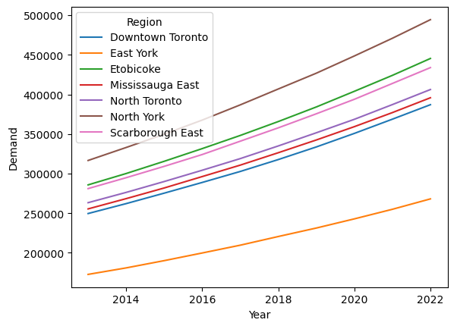

Quadratic spline was used to predict the demands in 2023, 2024, and 2025. By examining the continuity of demands and comparing the fitness to past demand values, it was determined that the quadratic spline could be used to predict future demands. The differences between the demand values of the quadratic spline and the historical values from 2013 to 2022 are minimum and almost zero. The line chart below shows the historical demand data (opaque) as well as the forecast demand data (transparent).

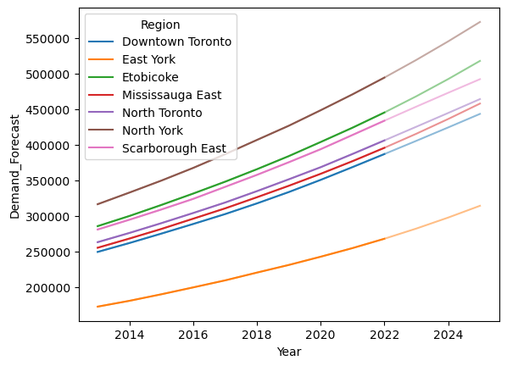

## Optimization Model

In order to optimize the supply chain of ComfortHealth and reduce costs, a mathematical model was built. Linear programming was used to find the optimized solution. The model was built based on the following assumptions.

* ComfortHealth must meet all demands.
* New centers can only be opened in 2023.
* Once a center is opened, an operating cost is incurred every year.
* Health professionals (HPs) cannot be fired.
* Centers cannot be closed.
* There is no other income other than the reimbursement from the government.
* Each HP is paid a standard rate of $37.85 per hour worked with an annual increase rate of 2.5%.
* A regular shift of an HP is 6 (or less) hours per day.
* An HP works at most 250 days a year.
* Hiring cost of a new HP is $15,000.
* No more than 300 employees may be hired in a year per service center.
* The cost of an HP travelling between centers and regions is $0.25 per kilometre and hour worked.
* Each home care visit is reimbursed by the government for a rate of $42 per hour.
* The time to visit multiple patients within a region is considered negligible.

The decision variables include the following.

* Number of HP work hours in each center each year
* Whether centers are operating
* Whether new centers are opened
* Number of new HPs hired in each center each year
* Number of HPs assigned to each center each year

Based on these assumptions, a mathematical model is constructed and is shown in the Appendix. The goal of the model is to minimize costs while meeting the demands.

Although the model is configured to meet all demands, it was found that the optimal solutions produced by the model cannot satisfy all demands every year. This report is constructed using the available results from the model. However, it should be noted that future analysis and examination are needed to improve the existing model.

## Investment in New Centers

According to the optimal solutions from the model, ComfortHealth should invest in opening Center E. This new center will supply to Downtown Toronto, Etobicoke, and North Toronto. In 2023, 87 HPs should be hired, and an additional four should be hired in the following year.

If ComfortHealth does not have to meet all demands, Center E is still worth investing in, but only 58 HPs are required to be hired in the first year.

Based on the result of the model, Center F should not be opened in 2023. By examining the distance and demand data, it can be noted that Center E is on average closer to all regions compared to Center F. The two bar charts below show the distance from Center E and Center F to each region.

## Recruitment

If ComfortHealth needs to meet all demands, 91 new HPs are needed to be allocated to Center E. As discussed previously, 87 HPs will be needed in 2023. Four HPs are needed to be hired in 2024 at Center E. According to the result of the model, no hiring is needed for other centers in the coming years.

However, by calculating the number of hours, it was found that this will not satisfy all demands for some unknown reasons. Therefore, further investigation needs to be performed to improve the model to ensure the effectiveness of constraints.

## Health Professional Assignment

A comprehensive HP assignment schedule is attached to this report in Appendix B. It can be noted that the model allocates most of the HPs to center C which has 432 HPs. Center A, B, and D are given 64, 33, and 31 HPs, respectively. Starting from 2023, Center E will recruit new HPs to satisfy the increasing demands.

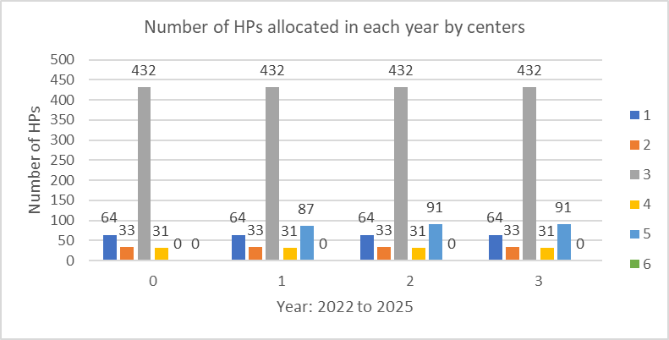

The following chart shows that the average number of HPs allocated to each region from 2023 to 2025. It can be seen that an increasing number of HPs are needed in total, but the average numbers of HPs sent to each region remain the same.

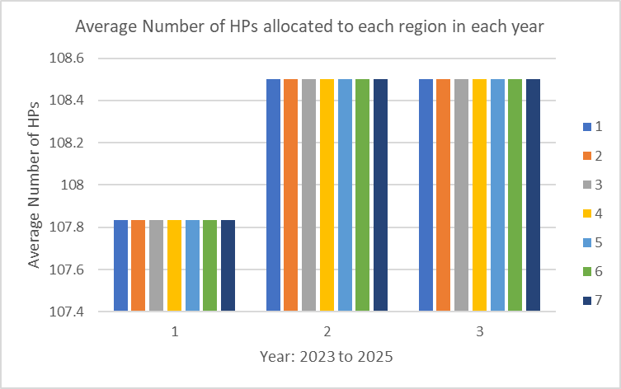

## Acceptance Rate of Patients

Since ComfortHealth is concerned about the impact of rejecting too many patients, two scenarios were explored with the existing model.

When the model is constrained to meet all demands in all regions, it was estimated that ComfortHealth will be able to produce a profit of $133,756,83.

When ComfortHealth has full accept/reject flexibility, the model estimates that ComfortHealth will be able to produce a profit of $177,816,35.

By relaxing requirement to meet all demands, more profit can be generated. According to the mode, around 84.2% of demands can be satisfied if it is not mandatary to meet all demands. It seems to be a reasonable patient acceptance rate. There is about 25% chance that ComfortHealth will reject the patience. However, most patients should be successfully referred to ComfortHealth, limiting the inconvenience of the doctors. More tests still need to be performed to evaluate the impact of rejections on the business.

## Appendix

### Appendix A

Mathematical Model

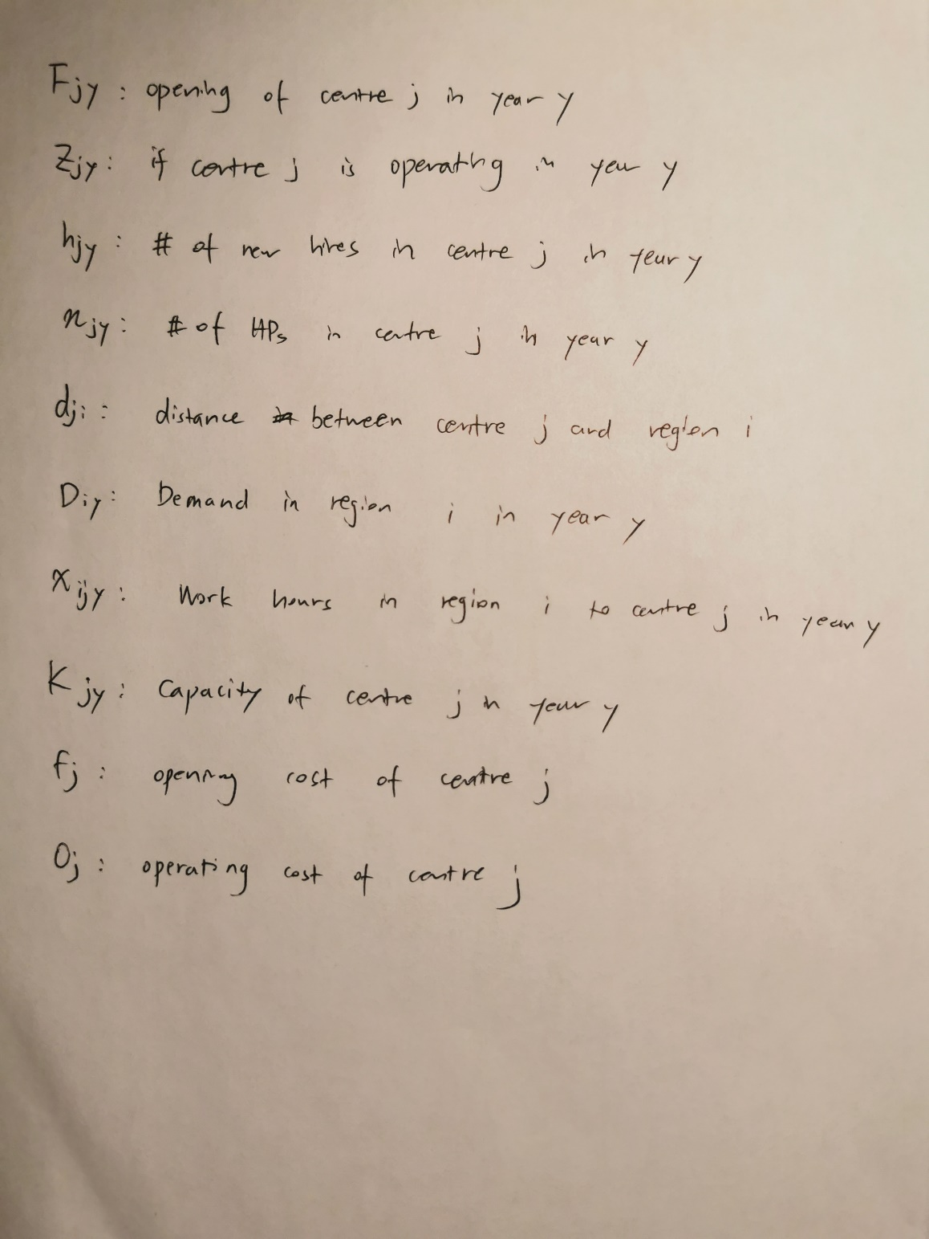

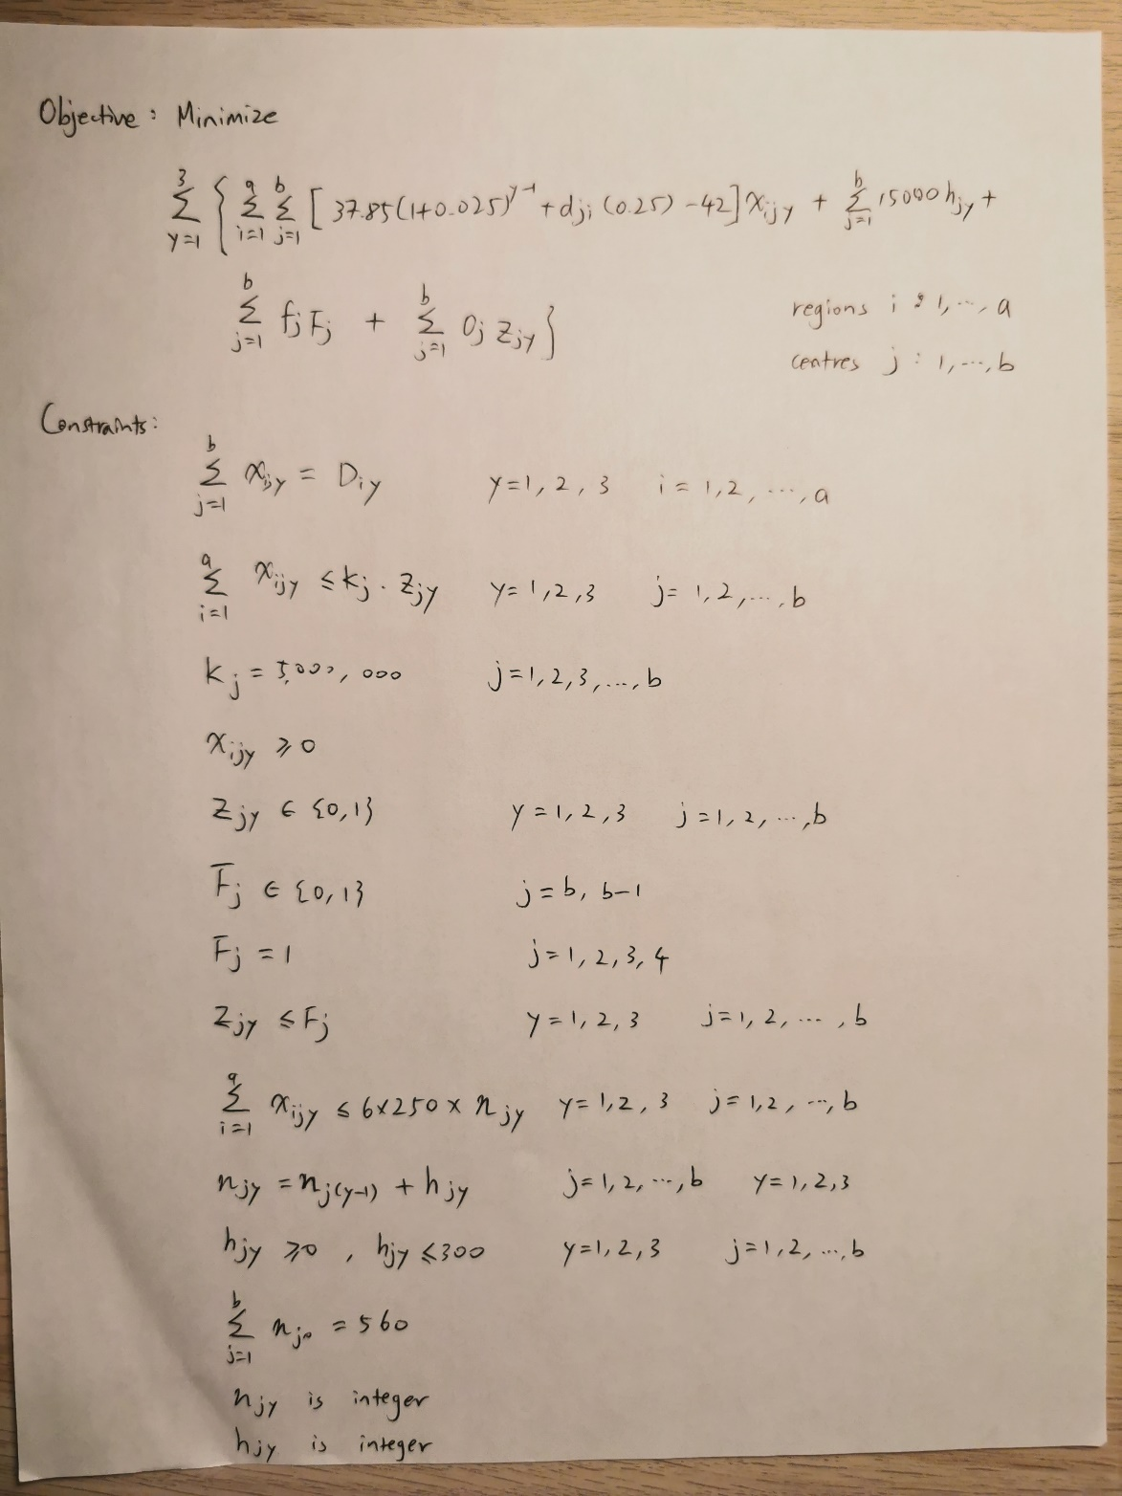

### Appendix B

Years:

* 0 – 2022
* 1 – 2023
* 2 – 2024
* 3 – 2025

Centers:

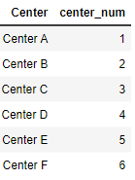

Regions:

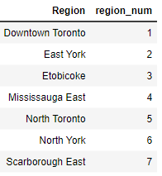

|  |  |  |  |  |  |  |  |  |
| --- | --- | --- | --- | --- | --- | --- | --- | --- |
| **Index** | **Year** | **Center** | **Region** | **Opened?** | **Operating?** | **HP Number** | **Total Hours** | **New Hires** |
| 0 | 0 | 1 | 1 | 1 | 1 | 64 |  |  |
| 1 | 1 | 1 | 1 | 1 | 1 | 64 | 0 | 0 |
| 2 | 2 | 1 | 1 | 1 | 1 | 64 | 0 | 0 |
| 3 | 3 | 1 | 1 | 1 | 1 | 64 | 0 | 0 |
| 4 | 0 | 1 | 2 | 1 | 1 | 64 |  |  |
| 5 | 1 | 1 | 2 | 1 | 1 | 64 | 282352.17 | 0 |
| 6 | 2 | 1 | 2 | 1 | 1 | 64 | 297783.51 | 0 |
| 7 | 3 | 1 | 2 | 1 | 1 | 64 | 314362.02 | 0 |
| 8 | 0 | 1 | 3 | 1 | 1 | 64 |  |  |
| 9 | 1 | 1 | 3 | 1 | 1 | 64 | 0 | 0 |
| 10 | 2 | 1 | 3 | 1 | 1 | 64 | 0 | 0 |
| 11 | 3 | 1 | 3 | 1 | 1 | 64 | 60390.919 | 0 |
| 12 | 0 | 1 | 4 | 1 | 1 | 64 |  |  |
| 13 | 1 | 1 | 4 | 1 | 1 | 64 | 0 | 0 |
| 14 | 2 | 1 | 4 | 1 | 1 | 64 | 0 | 0 |
| 15 | 3 | 1 | 4 | 1 | 1 | 64 | 0 | 0 |
| 16 | 0 | 1 | 5 | 1 | 1 | 64 |  |  |
| 17 | 1 | 1 | 5 | 1 | 1 | 64 | 0 | 0 |
| 18 | 2 | 1 | 5 | 1 | 1 | 64 | 0 | 0 |
| 19 | 3 | 1 | 5 | 1 | 1 | 64 | 0 | 0 |
| 20 | 0 | 1 | 6 | 1 | 1 | 64 |  |  |
| 21 | 1 | 1 | 6 | 1 | 1 | 64 | 519153.85 | 0 |
| 22 | 2 | 1 | 6 | 1 | 1 | 64 | 545193.55 | 0 |
| 23 | 3 | 1 | 6 | 1 | 1 | 64 | 572505.09 | 0 |
| 24 | 0 | 1 | 7 | 1 | 1 | 64 |  |  |
| 25 | 1 | 1 | 7 | 1 | 1 | 64 | 0 | 0 |
| 26 | 2 | 1 | 7 | 1 | 1 | 64 | 0 | 0 |
| 27 | 3 | 1 | 7 | 1 | 1 | 64 | 0 | 0 |
| 28 | 0 | 2 | 1 | 1 | 1 | 33 |  |  |
| 29 | 1 | 2 | 1 | 1 | 1 | 33 | 0 | 0 |
| 30 | 2 | 2 | 1 | 1 | 1 | 33 | 0 | 0 |
| 31 | 3 | 2 | 1 | 1 | 1 | 33 | 0 | 0 |
| 32 | 0 | 2 | 2 | 1 | 1 | 33 |  |  |
| 33 | 1 | 2 | 2 | 1 | 1 | 33 | 0 | 0 |
| 34 | 2 | 2 | 2 | 1 | 1 | 33 | 0 | 0 |
| 35 | 3 | 2 | 2 | 1 | 1 | 33 | 0 | 0 |
| 36 | 0 | 2 | 3 | 1 | 1 | 33 |  |  |
| 37 | 1 | 2 | 3 | 1 | 1 | 33 | 0 | 0 |
| 38 | 2 | 2 | 3 | 1 | 1 | 33 | 0 | 0 |
| 39 | 3 | 2 | 3 | 1 | 1 | 33 | 0 | 0 |
| 40 | 0 | 2 | 4 | 1 | 1 | 33 |  |  |
| 41 | 1 | 2 | 4 | 1 | 1 | 33 | 0 | 0 |
| 42 | 2 | 2 | 4 | 1 | 1 | 33 | 0 | 0 |
| 43 | 3 | 2 | 4 | 1 | 1 | 33 | 0 | 0 |
| 44 | 0 | 2 | 5 | 1 | 1 | 33 |  |  |
| 45 | 1 | 2 | 5 | 1 | 1 | 33 | 0 | 0 |
| 46 | 2 | 2 | 5 | 1 | 1 | 33 | 0 | 0 |
| 47 | 3 | 2 | 5 | 1 | 1 | 33 | 0 | 0 |
| 48 | 0 | 2 | 6 | 1 | 1 | 33 |  |  |
| 49 | 1 | 2 | 6 | 1 | 1 | 33 | 0 | 0 |
| 50 | 2 | 2 | 6 | 1 | 1 | 33 | 0 | 0 |
| 51 | 3 | 2 | 6 | 1 | 1 | 33 | 0 | 0 |
| 52 | 0 | 2 | 7 | 1 | 1 | 33 |  |  |
| 53 | 1 | 2 | 7 | 1 | 1 | 33 | 453575.15 | 0 |
| 54 | 2 | 2 | 7 | 1 | 1 | 33 | 473011.46 | 0 |
| 55 | 3 | 2 | 7 | 1 | 1 | 33 | 492153.91 | 0 |
| 56 | 0 | 3 | 1 | 1 | 1 | 432 |  |  |
| 57 | 1 | 3 | 1 | 1 | 1 | 432 | 0 | 0 |
| 58 | 2 | 3 | 1 | 1 | 1 | 432 | 0 | 0 |
| 59 | 3 | 3 | 1 | 1 | 1 | 432 | 0 | 0 |
| 60 | 0 | 3 | 2 | 1 | 1 | 432 |  |  |
| 61 | 1 | 3 | 2 | 1 | 1 | 432 | 0 | 0 |
| 62 | 2 | 3 | 2 | 1 | 1 | 432 | 0 | 0 |
| 63 | 3 | 3 | 2 | 1 | 1 | 432 | 0 | 0 |
| 64 | 0 | 3 | 3 | 1 | 1 | 432 |  |  |
| 65 | 1 | 3 | 3 | 1 | 1 | 432 | 0 | 0 |
| 66 | 2 | 3 | 3 | 1 | 1 | 432 | 0 | 0 |
| 67 | 3 | 3 | 3 | 1 | 1 | 432 | 0 | 0 |
| 68 | 0 | 3 | 4 | 1 | 1 | 432 |  |  |
| 69 | 1 | 3 | 4 | 1 | 1 | 432 | 0 | 0 |
| 70 | 2 | 3 | 4 | 1 | 1 | 432 | 0 | 0 |
| 71 | 3 | 3 | 4 | 1 | 1 | 432 | 0 | 0 |
| 72 | 0 | 3 | 5 | 1 | 1 | 432 |  |  |
| 73 | 1 | 3 | 5 | 1 | 1 | 432 | 0 | 0 |
| 74 | 2 | 3 | 5 | 1 | 1 | 432 | 0 | 0 |
| 75 | 3 | 3 | 5 | 1 | 1 | 432 | 0 | 0 |
| 76 | 0 | 3 | 6 | 1 | 1 | 432 |  |  |
| 77 | 1 | 3 | 6 | 1 | 1 | 432 | 0 | 0 |
| 78 | 2 | 3 | 6 | 1 | 1 | 432 | 0 | 0 |
| 79 | 3 | 3 | 6 | 1 | 1 | 432 | 0 | 0 |
| 80 | 0 | 3 | 7 | 1 | 1 | 432 |  |  |
| 81 | 1 | 3 | 7 | 1 | 1 | 432 | 0 | 0 |
| 82 | 2 | 3 | 7 | 1 | 1 | 432 | 0 | 0 |
| 83 | 3 | 3 | 7 | 1 | 1 | 432 | 0 | 0 |
| 84 | 0 | 4 | 1 | 1 | 1 | 31 |  |  |
| 85 | 1 | 4 | 1 | 1 | 1 | 31 | 0 | 0 |
| 86 | 2 | 4 | 1 | 1 | 1 | 31 | 0 | 0 |
| 87 | 3 | 4 | 1 | 1 | 1 | 31 | 0 | 0 |
| 88 | 0 | 4 | 2 | 1 | 1 | 31 |  |  |
| 89 | 1 | 4 | 2 | 1 | 1 | 31 | 0 | 0 |
| 90 | 2 | 4 | 2 | 1 | 1 | 31 | 0 | 0 |
| 91 | 3 | 4 | 2 | 1 | 1 | 31 | 0 | 0 |
| 92 | 0 | 4 | 3 | 1 | 1 | 31 |  |  |
| 93 | 1 | 4 | 3 | 1 | 1 | 31 | 0 | 0 |
| 94 | 2 | 4 | 3 | 1 | 1 | 31 | 0 | 0 |
| 95 | 3 | 4 | 3 | 1 | 1 | 31 | 0 | 0 |
| 96 | 0 | 4 | 4 | 1 | 1 | 31 |  |  |
| 97 | 1 | 4 | 4 | 1 | 1 | 31 | 415488.1 | 0 |
| 98 | 2 | 4 | 4 | 1 | 1 | 31 | 436193.29 | 0 |
| 99 | 3 | 4 | 4 | 1 | 1 | 31 | 457883.58 | 0 |
| 100 | 0 | 4 | 5 | 1 | 1 | 31 |  |  |
| 101 | 1 | 4 | 5 | 1 | 1 | 31 | 0 | 0 |
| 102 | 2 | 4 | 5 | 1 | 1 | 31 | 0 | 0 |
| 103 | 3 | 4 | 5 | 1 | 1 | 31 | 0 | 0 |
| 104 | 0 | 4 | 6 | 1 | 1 | 31 |  |  |
| 105 | 1 | 4 | 6 | 1 | 1 | 31 | 0 | 0 |
| 106 | 2 | 4 | 6 | 1 | 1 | 31 | 0 | 0 |
| 107 | 3 | 4 | 6 | 1 | 1 | 31 | 0 | 0 |
| 108 | 0 | 4 | 7 | 1 | 1 | 31 |  |  |
| 109 | 1 | 4 | 7 | 1 | 1 | 31 | 0 | 0 |
| 110 | 2 | 4 | 7 | 1 | 1 | 31 | 0 | 0 |
| 111 | 3 | 4 | 7 | 1 | 1 | 31 | 0 | 0 |
| 112 | 0 | 5 | 1 | 0 | 0 | 0 |  |  |
| 113 | 1 | 5 | 1 | 0 | 1 | 87 | 405549.17 | 87 |
| 114 | 2 | 5 | 1 | 0 | 1 | 91 | 424348.52 | 4 |
| 115 | 3 | 5 | 1 | 0 | 1 | 91 | 443401.03 | 0 |
| 116 | 0 | 5 | 2 | 0 | 0 | 0 |  |  |
| 117 | 1 | 5 | 2 | 0 | 1 | 87 | 0 | 87 |
| 118 | 2 | 5 | 2 | 0 | 1 | 91 | 0 | 4 |
| 119 | 3 | 5 | 2 | 0 | 1 | 91 | 0 | 0 |
| 120 | 0 | 5 | 3 | 0 | 0 | 0 |  |  |
| 121 | 1 | 5 | 3 | 0 | 1 | 87 | 468109.93 | 87 |
| 122 | 2 | 5 | 3 | 0 | 1 | 91 | 492257.8 | 4 |
| 123 | 3 | 5 | 3 | 0 | 1 | 91 | 457421.68 | 0 |
| 124 | 0 | 5 | 4 | 0 | 0 | 0 |  |  |
| 125 | 1 | 5 | 4 | 0 | 1 | 87 | 0 | 87 |
| 126 | 2 | 5 | 4 | 0 | 1 | 91 | 0 | 4 |
| 127 | 3 | 5 | 4 | 0 | 1 | 91 | 0 | 0 |
| 128 | 0 | 5 | 5 | 0 | 0 | 0 |  |  |
| 129 | 1 | 5 | 5 | 0 | 1 | 87 | 425322.55 | 87 |
| 130 | 2 | 5 | 5 | 0 | 1 | 91 | 444665.64 | 4 |
| 131 | 3 | 5 | 5 | 0 | 1 | 91 | 464177.28 | 0 |
| 132 | 0 | 5 | 6 | 0 | 0 | 0 |  |  |
| 133 | 1 | 5 | 6 | 0 | 1 | 87 | 0 | 87 |
| 134 | 2 | 5 | 6 | 0 | 1 | 91 | 0 | 4 |
| 135 | 3 | 5 | 6 | 0 | 1 | 91 | 0 | 0 |
| 136 | 0 | 5 | 7 | 0 | 0 | 0 |  |  |
| 137 | 1 | 5 | 7 | 0 | 1 | 87 | 0 | 87 |
| 138 | 2 | 5 | 7 | 0 | 1 | 91 | 0 | 4 |
| 139 | 3 | 5 | 7 | 0 | 1 | 91 | 0 | 0 |
| 140 | 0 | 6 | 1 | 0 | 0 | 0 |  |  |
| 141 | 1 | 6 | 1 | 0 | 0 | 0 | 0 | 0 |
| 142 | 2 | 6 | 1 | 0 | 0 | 0 | 0 | 0 |
| 143 | 3 | 6 | 1 | 0 | 0 | 0 | 0 | 0 |
| 144 | 0 | 6 | 2 | 0 | 0 | 0 |  |  |
| 145 | 1 | 6 | 2 | 0 | 0 | 0 | 0 | 0 |
| 146 | 2 | 6 | 2 | 0 | 0 | 0 | 0 | 0 |
| 147 | 3 | 6 | 2 | 0 | 0 | 0 | 0 | 0 |
| 148 | 0 | 6 | 3 | 0 | 0 | 0 |  |  |
| 149 | 1 | 6 | 3 | 0 | 0 | 0 | 0 | 0 |
| 150 | 2 | 6 | 3 | 0 | 0 | 0 | 0 | 0 |
| 151 | 3 | 6 | 3 | 0 | 0 | 0 | 0 | 0 |
| 152 | 0 | 6 | 4 | 0 | 0 | 0 |  |  |
| 153 | 1 | 6 | 4 | 0 | 0 | 0 | 0 | 0 |
| 154 | 2 | 6 | 4 | 0 | 0 | 0 | 0 | 0 |
| 155 | 3 | 6 | 4 | 0 | 0 | 0 | 0 | 0 |
| 156 | 0 | 6 | 5 | 0 | 0 | 0 |  |  |
| 157 | 1 | 6 | 5 | 0 | 0 | 0 | 0 | 0 |
| 158 | 2 | 6 | 5 | 0 | 0 | 0 | 0 | 0 |
| 159 | 3 | 6 | 5 | 0 | 0 | 0 | 0 | 0 |
| 160 | 0 | 6 | 6 | 0 | 0 | 0 |  |  |
| 161 | 1 | 6 | 6 | 0 | 0 | 0 | 0 | 0 |
| 162 | 2 | 6 | 6 | 0 | 0 | 0 | 0 | 0 |
| 163 | 3 | 6 | 6 | 0 | 0 | 0 | 0 | 0 |
| 164 | 0 | 6 | 7 | 0 | 0 | 0 |  |  |
| 165 | 1 | 6 | 7 | 0 | 0 | 0 | 0 | 0 |
| 166 | 2 | 6 | 7 | 0 | 0 | 0 | 0 | 0 |
| 167 | 3 | 6 | 7 | 0 | 0 | 0 | 0 | 0 |